**CHAPTER 2**

**HARDWARE DESIGN**

**2.1 BLOCK DIAGRAM**

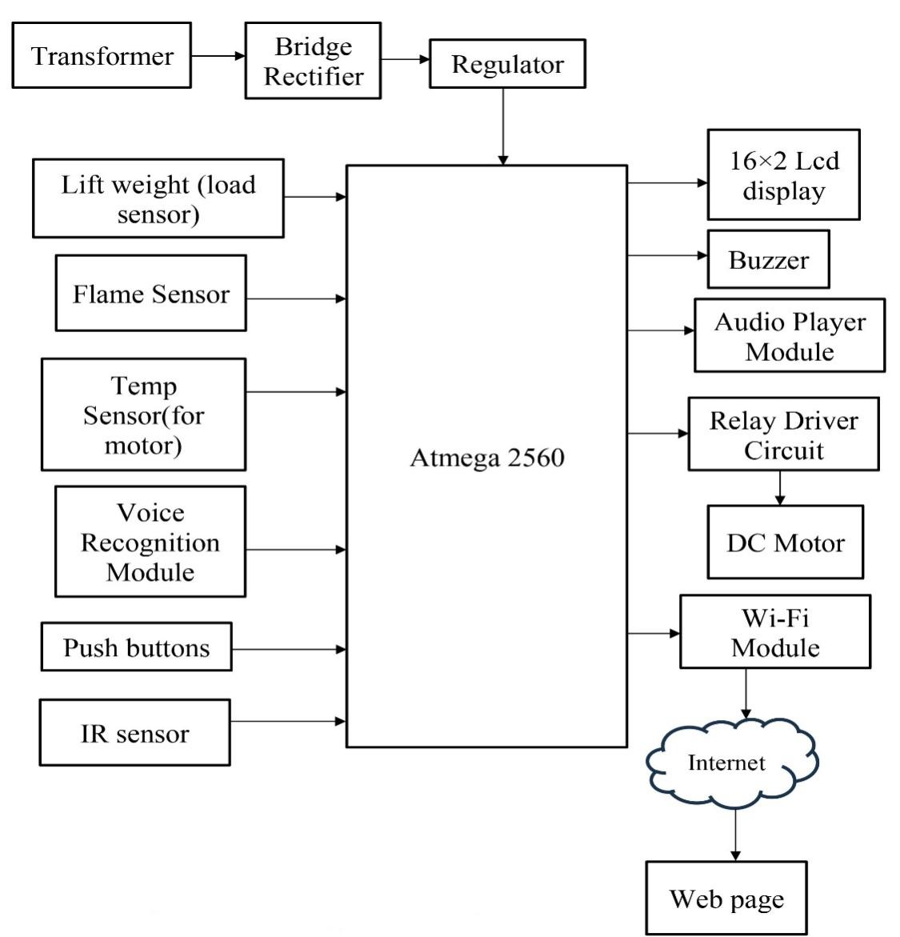

Fig.1: Block Diagram

2.1.1 BLOCK DIAGRAM DESCRIPTION:

This is description of below block diagram. Here the rectifier is used as a component of power supply. The 230V AC is step down to 12V AC using transformer and is rectified to 12V DC by the rectifier. LM7805 is used as the voltage regulator, which regulates the voltage to 5V [6]. The voice recognition system is the main part of this project. Voice recognition module is communication mechanism between the user and microcontroller. The project will make the use of DC motor for the moving of lift. Microcontroller is programmed, with the help of embedded C programming. The microcontroller can communicate with all input and output modules of elevator.

The Wi-Fi module is used for the wireless connection between the server and controller. The microcontroller processes the received voice commands using a voice recognition module. Based on the recognized voice commands, the microcontroller's control logic will determine the appropriate actions to control the elevator, interfacing with the elevator's control circuitry and motor drivers to execute the commands accurately [7]. Load sensors placed within the elevator continuously monitor the weight of the carriage and passengers, ensuring that the elevator does not exceed its maximum weight capacity for safe operation.

The voice recognition module desires to be trained first earlier than it could be used to apprehend instructions. Upon a success recognition of voice command, the microcontroller drives the corresponding load with the assist of the relay circuit [10]. Additionally, the microcontroller incorporates safety mechanisms such as voice-activated emergency stop, weight limit warnings, and vocal confirmation of emergency messages to enhance passenger safety. The elevator's server integration allows for remote monitoring, and data visualization. Building administrators, maintenance personnel, and emergency response teams can remotely manage the elevator's operations, access real-time data, and optimize performance through a dedicated webpage. Overall, this voice-controlled elevator system provides an innovative, user-friendly, and safe elevator experience for passengers while optimizing energy efficiency and offering convenient remote management capabilities.

**2.2 COMPONENTS REQUIRED:**

**2.2.1 Arduino Mega:**

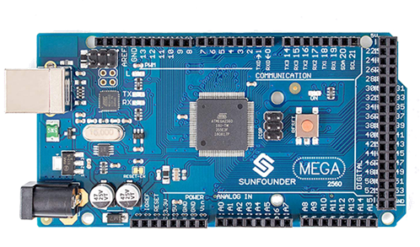

Fig.2: ATMEGA328P Microcontroller

The Arduino Mega, a member of the Arduino microcontroller platform, is a remarkable development board that offers an extensive range of features and capabilities. It is based on the ATmega2560 microcontroller, which provides ample processing power, a variety of input and output pins, and extensive memory for program storage. The Mega is an ideal choice for complex projects, allowing for the creation of sophisticated electronic systems and automation applications.

Technical Specifications:

1. Microcontroller: The heart of the Arduino Mega is the ATmega2560 microcontroller, running at a clock speed of 16 MHz This microcontroller is equipped with 256 KB of flash memory for program storage, 8 KB of SRAM for data storage, and 4 KB of EEPROM for non-volatile data storage.
2. Digital Pins: It features a total of 54 digital input/output pins, of which 15 can be used for pulse-width modulation (PWM) output. These pins provide ample opportunities for connecting various sensors, actuators, and external components.
3. Analog Inputs: The board is equipped with 16 analog inputs, making it suitable for projects that require the measurement of analog signals such as sensor readings.
4. Communication Interfaces: The Mega supports a range of communication interfaces, including UART, SPI, and I2C, enabling it to interact with other devices and microcontrollers.
5. Operating Voltage: The operating voltage for the Arduino Mega is 5V, making it compatible with a wide range of sensors and peripherals.
6. Power Supply: The board can be powered via a USB connection, an external power supply, or a battery. It also features a built-in voltage regulator, ensuring a stable power supply for the connected components.
7. Features and Capabilities: The Arduino Mega's impressive array of features and capabilities has made it a go-to choose for a variety of projects:
8. Ample I/O Pins: With 54 digital I/O pins and 16 analog input pins, the Mega offers a vast number of options for connecting and controlling a wide range of sensors, actuators, and other electronic components.
9. Memory Resources: The substantial flash memory, SRAM, and EEPROM on the ATmega2560 provide plenty of room for complex program code, data storage, and the creation of intricate applications.
10. Multiple Communication Options: The board's support for various communication protocols, including UART, SPI, and I2C, facilitates data exchange with other devices, enabling it to function as the central controller in intricate communication networks.
11. Extensible: The Arduino Mega is extensible using shields, which are accessory boards that can be stacked on top of the Mega. These shields can add functionality such as Ethernet connectivity, wireless communication, and more, making the Mega even more versatile.
12. Community Support: The Arduino platform, including the Mega, benefits from a vast and active community of developers and enthusiasts. This means there is a wealth of tutorials, libraries, and resources available for users to tap into.
13. Open-Source: As with all Arduino boards, the Arduino Mega is open-source, which means its design and software are freely available for anyone to study, modify, and share. This open philosophy has contributed to the widespread adoption of Arduino and its boards.

Applications:

1. Home Automation: It can be used to create home automation systems for controlling lights, appliances, and climate control.
2. Robotics: The Mega is a popular choice for robotics projects, where it can control motors, sensors, and navigation systems.
3. Data Acquisition: Its numerous analog inputs make it ideal for data acquisition applications, such as environmental monitoring and data logging.
4. Industrial Control: The board is well-suited for industrial automation and control systems, managing various processes and sensors.
5. 3D Printing and CNC Machines: It can control 3D printers and CNC machines, precisely moving motors and interpreting G-code commands.
6. Interactive Art: Arduino Mega is often used in interactive art installations, where it can process inputs from sensors and provide outputs for various artistic effects.
7. Impact and Significance: The Arduino Mega, as a part of the Arduino ecosystem, has had a significant impact on the world of electronics and automation. Here are some of the key contributions:
8. Education: The accessibility and ease of use of the Arduino platform, including the Mega, have made it a valuable tool for teaching electronics and programming in educational institutions worldwide.
9. Rapid Prototyping: Arduino Mega and other Arduino boards are widely used for rapid prototyping of electronic projects. This has greatly accelerated the development of innovative ideas and products.
10. Community Collaboration: The open-source nature of Arduino has fostered a collaborative community of enthusiasts, makers, and professionals who freely share their knowledge and contribute to a vast library of open-source code and projects.
11. Democratization of Electronics: Arduino has made electronics and embedded systems accessible to a wider audience, breaking down barriers for those who wish to experiment, create, and innovate in the field of electronics.

PIN DIAGRAM:

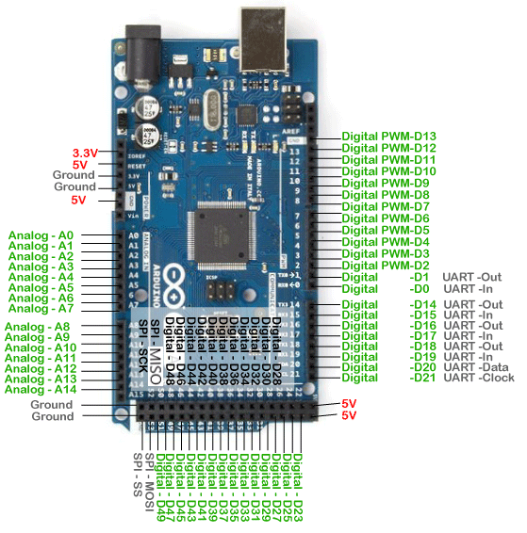

Fig.3: Pin Configuration of Arduino mega

Digital Pins:

1. Digital Pins 0-53: There are 54 digital pins on the Arduino Mega 2560, labelled from 0 to 53. These pins can be used for both input and output, and some of them have additional functions like PWM (Pulse Width Modulation) and interrupt capabilities.
2. PWM Pins: Digital pins 2 to 13 and 44 to 46 can be used for PWM output. They can generate analog-like output for tasks such as controlling the speed of DC motors or the brightness of LEDs.
3. Interrupt Pins: Digital pins 2, 3, 18, 19, 20, and 21 can be used as external interrupt pins, allowing the Arduino to respond to external events.

Analog Pins:

1. Analog Pins 0-15: The Arduino Mega has 16 analog input pins labelled A0 to A15. These pins can be used to read analog voltage levels from sensors and other analog devices.
2. Special Pins:
3. TX (Transmit) and RX (Receive): Pins 0 (RX) and 1 (TX) are used for serial communication with your computer or other devices.
4. RESET: The RESET pin can be used to reset the microcontroller.
5. Communication Interfaces:
6. I2C: The Mega supports the I2C communication protocol, which is accessible through pins 20 (SDA) and 21 (SCL).
7. SPI: The Serial Peripheral Interface (SPI) communication protocol can be used with pins 50 (MISO), 51 (MOSI), 52 (SCK), and 53 (SS).
8. Power Supply and Ground Pins:
9. 5V: The 5V pins provide a 5-volt power supply. There are multiple 5V pins on the board.
10. 3.3V: The 3.3V pins provide a 3.3-volt power supply. There are multiple 3.3V pins on the board.
11. Vin: The Vin pin allows you to power the board using an external power source (e.g., a battery or an external power adapter).
12. GND: There are multiple Ground (GND) pins available for connecting the ground of your circuits.

Other Pins:

1. AREF: The AREF (Analog Reference) pin is used to provide an external reference voltage for the analog-to-digital converter (ADC).
2. L: The L (TX) and L (RX) LEDs indicate data transmission and reception over the serial interface.

**2.2.2 Load cell**

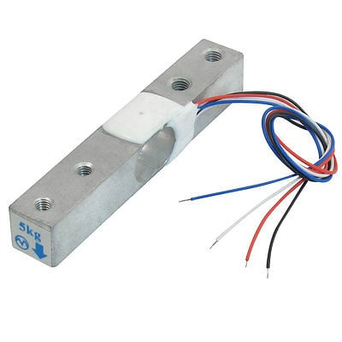

Fig.4: Load cell

This straight bar load cell (sometimes called a strain gauge) can translate up to 5 kg of pressure (force) into an electrical signal. Each load cell can measure the electrical resistance that changes in response to, and proportional of, the strain (e.g., pressure or force) applied to the bar.

With this gauge, you will be able to tell just how heavy an object is, if an object’s weight changes over time, or if you simply need to sense the presence of an object by measuring strain or load applied to a surface. This straight bar load cell is made from an aluminium alloy and can read a capacity of 1KG of weight

It has Four lead wires which can be connected to HX711 A/D Pressure Sensor. It is easy to use with driving voltage 5-10V and produce the output voltage as per the force changes over it.

Installation of the Sensor is also the simple task, it needs to fix one end through the screw hole and the other end left floating state, according to the label indicates the direction of the gravitational force exerted particular attention must not directly push the white plastic cover part of the sensor to avoid damage.

Specifications:

|  |  |
| --- | --- |
| Model | YZC-131A |
| Material | Aluminum |
| Dimensions in mm (LxWxH) | 75x13x13 |
| Weighing Range (Kg) | 0 ~ 5 |
| Rated Output | 1.0 ± 0.1mV / V |
| Non-Linear Output | ± 0.03% F.S |
| Hysteresis | 0.0% F.S |
| Repeatability | 0.05% F.S |
| Creep | (5 minutes) 0.05% F.S |
| Cable Length (cm) | 18 |
| Zero Balance | ± 0.1 mV / V |
| Impedance (Ω) | 1066 ± 10% Ω |
| Output Impedance | 1000 ± 10% Ω |
| Temperature Effect on Output | 0.003% F.S / C |
| Operating Temperature Range (°C) | -21 to 40 |
| Weight (gm) | 29 |
| Insulation Resistance (MΩ) | 2000 |
| Shipment Weight | 0.08 kg |
| Shipment Dimensions | 8 × 3 × 1 cm |

**2.2.3 IR SENSOR:**

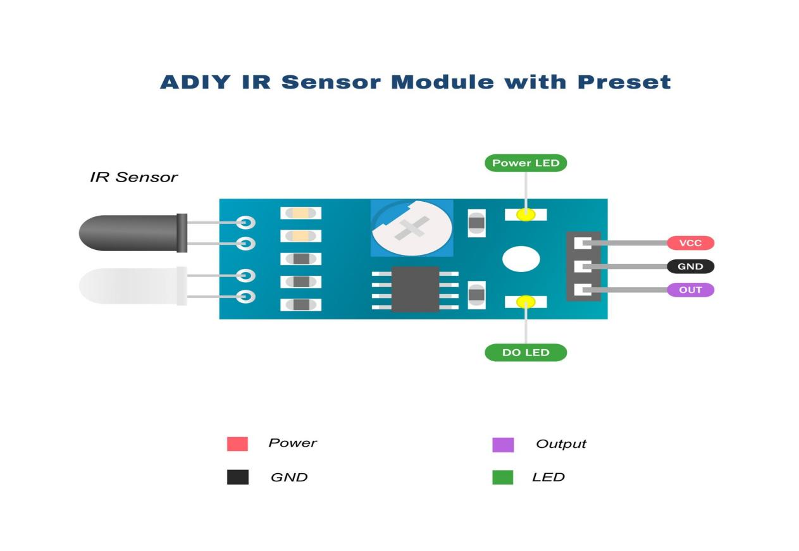

Fig.5: IR sensor

IR technology is used in daily life and also in industries for different purposes. For example, TVs use an IR sensor to understand the signals which are transmitted from a remote control. The main benefits of IR sensors are low power usage, their simple design & their convenient features. IR signals are not noticeable by the human eye. The IR radiation in the electromagnetic spectrum can be found in the regions of the visible & microwave. Usually, the wavelengths of these waves range from 0.7 µm 5 to 1000µm. The IR spectrum can be divided into three regions like near-infrared, mid, and far-infrared. The near IR region’s wavelength ranges from 0.75 – 3µm, the mid-infrared region’s wavelength ranges from 3 to 6µm & the far IR region’s infrared radiation’s wavelength is higher than 6µm.

What is an IR Sensor/Infrared Sensor?

An infrared sensor is an electronic device, that emits in order to sense some aspects of the surroundings. An IR sensor can measure the heat of an object as well as detects the motion. These types of sensors measure only infrared radiation, rather than emitting it that is called a passive IR sensor. Usually, in the infrared spectrum, all the objects radiate some form of thermal radiation.

Infrared Sensor

These types of radiations are invisible to our eyes, which can be detected by an infrared sensor. The emitter is simply an IR LED (Light Emitting Diode) and the detector is simply an IR photodiode that is sensitive to IR light of the same wavelength as that emitted by the IR LED. When IR light falls on the photodiode, the resistances and the output voltages will change in proportion to the magnitude of the IR light received.

Working Principle

The working principle of an infrared sensor is similar to the object detection sensor. This sensor includes an IR LED & an IR Photodiode, so by combining these two can be formed as a photo-coupler otherwise optocoupler. The physics laws used in this sensor are planks radiation, Stephan Boltzmann & weins displacement.

IR LED is one kind of transmitter that emits IR radiations. This LED looks similar to a standard LED and the radiation which is generated by this is not visible to the human eye. Infrared receivers mainly detect the radiation using an infrared transmitter. These infrared receivers are available in photodiodes form. IR Photodiodes are dissimilar as compared with usual photodiodes because they detect simply IR radiation. Different kinds of infrared receivers mainly exist depending on the voltage, wavelength, package, etc.

Once it is used as the combination of an IR transmitter & receiver, then the receiver’s wavelength must equal the transmitter. Here, the transmitter is IR LED whereas the receiver is IR photodiode. The infrared photodiode is responsive to the infrared light that is generated through an infrared LED. The resistance of photo-diode & the change in output voltage is in proportion to the infrared light obtained. This is the IR sensor’s fundamental working principle.

Once the infrared transmitter generates emission, then it arrives at the object & some of the emission will reflect back toward the infrared receiver. The sensor output can be decided by the IR receiver depending on the intensity of the response.

Types of Infrared Sensor

Infrared sensors are classified into two types like active IR sensor and passive IR sensor.

* Active IR Sensor

This active infrared sensor includes both the transmitter as well as the receiver. In most of the applications, the light-emitting diode is used as a source. LED is used as a non-imaging infrared sensor whereas the laser diode is used as an imaging infrared sensor.

These sensors work through energy radiation, received & detected through radiation. Further, it can be processed by using the signal processor to fetch the necessary information. The best examples of this active infrared sensor are reflectance and break beam sensor.

* Passive IR Sensor

The passive infrared sensor includes detectors only but they don’t include a transmitter. These sensors use an object like a transmitter or IR source. This object emits energy and detects through infrared receivers. After that, a signal processor is used to understand the signal to obtain the required information.

The best examples of this sensor are pyroelectric detector, bolometer, thermocouple-thermopile, etc. These sensors are classified into two types like thermal IR sensor and quantum IR sensor. The thermal IR sensor doesn’t depend on wavelength. The energy source used by these sensors is heated. Thermal detectors are slow with their response and detection time. The quantum IR sensor depends on the wavelength and these sensors include high response and detection time. These sensors need regular cooling for specific measurements.

IR Sensor Circuit Diagram

An infrared sensor circuit is one of the basic and popular sensor modules in an electronic device. This sensor is analogous to human’s visionary senses, which can be used to detect obstacles and it is one of the common applications in real-time. This circuit comprises the following components

* LM358 IC 2 IR transmitter and receiver pair
* Resistors of the range of kilo-ohms.
* Variable resistors.
* LED (Light Emitting Diode).
* Infrared Sensor Circuit Diagram
* Infrared Sensor Circuit Diagram

In this project, the transmitter section includes an IR sensor, which transmits continuous IR rays to be received by an IR receiver module. An IR output terminal of the receiver varies depending upon its receiving of IR rays. Since this variation cannot be analysed as such, therefore this output can be fed to a comparator circuit. Here an operational amplifier (op-amp) of LM 339 is used as a comparator circuit.

When the IR receiver does not receive a signal, the potential at the inverting input goes higher than that non-inverting input of the comparator IC (LM339). Thus, the output of the comparator goes low, but the LED does not glow. When the IR receiver module receives a signal to the potential at the inverting input goes low. Thus, the output of the comparator (LM 339) goes high and the LED starts glowing.

Resistor R1 (100 ), R2 (10k ), and R3 (330) are used to ensure that a minimum of 10 mA current passes through the IR LED Devices like Photodiode and normal LEDs respectively. Resistor VR2 (preset=5k ) is used to adjust the output terminals. Resistor VR1 (preset=10k ) is used to set the sensitivity of the circuit Diagram. Read more about IR sensors.

IR Sensor Circuit using Transistor

The circuit diagram of the IR sensor using transistors namely obstacle detection using two transistors is shown below. This circuit is mainly used for obstacle detection using an IR LED. So, this circuit can be built with two transistors like NPN and PNP. For NPN, BC547 transistor is used whereas, for PNP, BC557 transistor is used. The pinout of these transistors is the same.

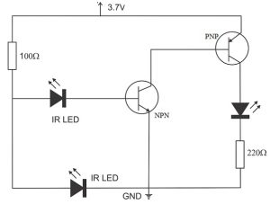

In the above circuit, one infrared LED is always switched on whereas the other infrared LED is allied to the PNP transistor’s base terminal because this IR LED acts as the detector. The required components of this IR sensor circuit include resistors 100 ohms & 200 ohms, BC547 & BC557 transistors, LED, IR LEDs-2. The step-by-step procedure of how to make the IR sensor circuit includes the following steps.

* Connect the components as per the circuit diagram using required components
* Connect one infrared LED to the BC547 transistor’s base terminal
* Connect an infrared LED to the base terminal of the same transistor.
* Connect the 100Ω resistor toward the residual pins of the infrared LEDs.
* Connect the base terminal of the PNP transistor toward the collector terminal of the NPN transistor.
* Connect the LED & 220Ω resistor as per the connection in the circuit diagram.
* Once the connection of the circuit is done then gives the power supply to the circuit for testing.

Circuit Working

Once the infrared LED is detected, then the reflected light from the thing will activate a small current that will supply throughout the IR LED detector. This will activate the NPN transistor & the PNP; therefore, the LED will switch ON. This circuit is applicable for making different projects like automatic lamps to activate once a person approaches close to the light.

Pin Description:

Table 3: Pin Description of IR

|  |  |  |
| --- | --- | --- |
| Pin No | Function | Name |
| 1 | Supply voltage; 5V (+35V to -2V) | Vcc |
| 2 | Output voltage (+5V to 1V) | Output |
| 3 | Ground (0V) | Ground |

**2.2.4. TRANSFORMER :**

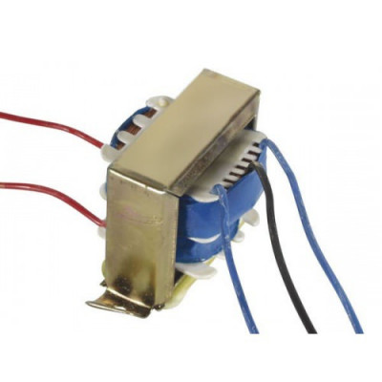

Fig.6: Transformers

12-0-12 2Amp Centre Tapped Step Down Transformer is a general-purpose chassis mounting mains transformer. Transformer has 230V primary winding and centre tapped secondary winding. The transformer has flying coloured insulated connecting leads ( Approx 100 mm long ). The Transformer act as step down transformer reducing AC - 230V to AC - 12V. The Transformer gives outputs of 12V, 12V and 0V. The Transformer's construction is written below with details of Solid Core and Winding.

The transformer is a static electrical device that transfers energy by inductive coupling between its winding circuits. A varying current in the primary winding creates a varying magnetic flux in the transformer's core and thus a varying magnetic flux through the secondary winding. This varying magnetic flux induces a varying electromotive force (E.M.F) or voltage in the secondary winding. The transformer has cores made of high permeability silicon steel. The steel has a permeability many times that of free space and the core thus serves to greatly reduce the magnetizing current and confine the flux to a path which closely couples the winding.

Specifications of 12-0-12 2 Ampere Centre Tapped Transformer:-

* Input Voltage: 230V AC
* Output Voltage: 12V, 12V or 0V
* Output Current: 2 Amp
* Mounting: Vertical mount type
* Winding: Copper
* Features of 12-0-12 2 Ampere Centre Tapped Transformer:-
* Soft Iron Core.
* 2 Amp Current Drain.
* 100% Copper Winding
* Applications of 12-0-12 2 Ampere Centre Tapped Transformer:-
* DIY projects Requiring In-Application High current drain.
* On chassis AC/AC converter.
* Designing a battery, Charger.

**2.2.5 16X2 LCD:**

LCD (Liquid Crystal Display) screen is an electronic display module and find a wide range of applications. A 16x2 LCD display is very basic module and is very commonly used in various devices and circuits. These modules are preferred over [seven segments](http://www.engineersgarage.com/content/seven-segment-display) and other multi segment [LED](http://www.engineersgarage.com/content/led)s. The reasons being: LCDs are economical; easily programmable; have no limitation of displaying special & even [custom characters](http://www.engineersgarage.com/microcontroller/8051projects/create-custom-characters-LCD-AT89C51) (unlike in seven segments), [animations](http://www.engineersgarage.com/microcontroller/8051projects/display-custom-animations-LCD-AT89C51) and so on.

A 16x2 LCD means it can display 16 characters per line and there are 2 such lines. In this LCD each character is displayed in 5x7 pixel matrix. This LCD has two registers, namely, Command and Data. The command register stores the command instructions given to the LCD. A command is an instruction given to LCD to do a predefined task like initializing it, clearing its screen, setting the cursor position, controlling display etc. The data register stores the data to be displayed on the LCD. The data is the ASCII value of the character to be displayed on the LCD. Click to learn more about internal structure of a [LCD](http://www.engineersgarage.com/insight/how-lcd-works).

The purpose of using 16x2 LCD in our project is to display all the parameters of solar panel and is connected to pin no 37 and 38 of microcontroller.

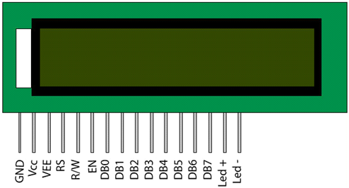

Fig.7: 16x2 LCD

Interface Pin Description:

Table 4: Pin description of 16x2 LCD

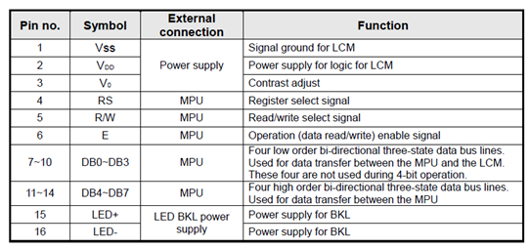

FEATURES:

* 16x2 matrix
* Low power operation support: 2.7 to 5.5V.
* Duty cycle: 1/16.
* Connector for standard 0.1-pitch pin headers.

**2.2.6 DC MOTOR:**

A [DC motor](https://www.electrical4u.com/dc-motor-or-direct-current-motor/) in simple words is a device that converts electrical energy (direct current system) into mechanical energy. Here we are using three DC motors, two are used to control the position of solar panel and one is used to control the wiper.

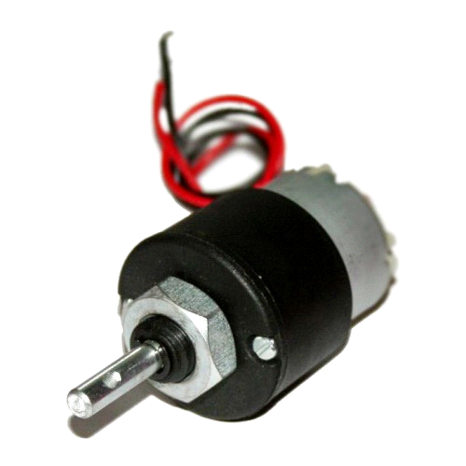

Fig.8: Motor

**2.2.7 RELAY:**

Relays are electromechanical switches. They have very high current rating and both AC and DC motors can be controlled through them because motor will be completely isolated from the remaining circuit. Relays are used as driving circuit for motor, they are used to rotate the motor in forward or reverse direction. Each motor uses two relays hence there are total 6 relays connected to pins of microcontroller which are 20-24.

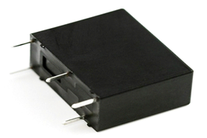

* Fig.9: Relay
* Normally Open (NO): Contacts connect the circuit when the relay is activated, the circuit is disconnected when the relay is inactive.
* Normally Closed (NC): Contacts disconnect the circuit when the relay is activated, the circuit is connected when the relay is inactive.

ChangeOver (CO): It’s the common contact.

Coil: It’s the electromagnet coil inside relay.

Relay ratings:

Coil rating: It’s the Voltage at which the coil gets fully activated. Some also have coil resistance mentioned on them. Relay coil voltage rated 6V and 12V are the most commonly available.

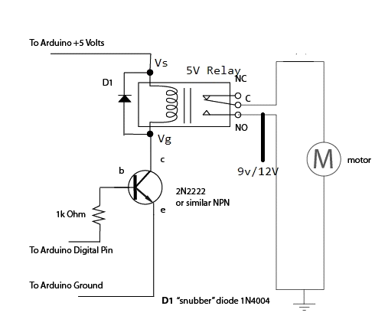

Fig.10: Motor and Motor Driver

**2.2.8 BUZZER:**

A buzzer or beeper is an audio signal device, which may be [mechanical](https://en.wikipedia.org/wiki/Machine), [electromechanical](https://en.wikipedia.org/wiki/Electromechanics), or [piezoelectric](https://en.wikipedia.org/wiki/Piezoelectricity). Typical uses of buzzers and beepers include [alarm devices](https://en.wikipedia.org/wiki/Alarm_devices), [timers](https://en.wikipedia.org/wiki/Timer) and confirmation of user input such as a mouse click or keystroke. If embedded system is misplaced from dashboard, the IR sensor becomes active. The signal is sent to microcontroller to ring the buzzer. It is connected to the pin no.28 of microcontroller.

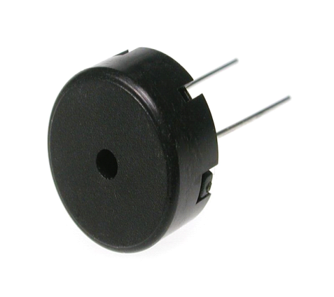

Fig.11: Buzzer

**2.2.9 OPTOCOUPLER PC817:**

PC817XNNSZ0F Series contains an IRED optically coupled to a phototransistor. It is packaged in a 4-pin DIP. Input-output isolation voltage(rms) is 5kV. Optocoupler is used to generate a pulse in order to control the charging of battery.

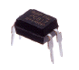

Fig.12: Optocoupler

Features

* 4-pin DIP package
* Double transfer mold package (Ideal for Flow Soldering)
* High isolation voltage between input and output (Viso(rms) : 5kV)
* High collector-emitter voltage(VCEO : 80V)
* Current transfer ratio (CTR : MIN. 50% at IF=5 mA, VCE=5V)

**2.2.10 TRANSISTOR BC547:**

A transistor is a semiconductor device used to amplify or switch electronic signal and electrical power. It is composed of semiconductor material usually with at least three terminals for connections to an external circuit.

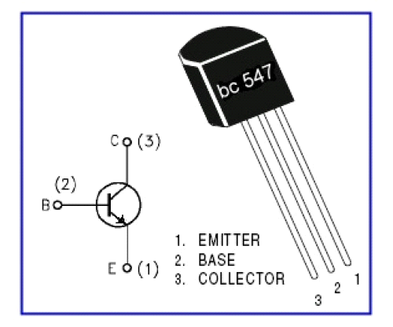

Fig.13: Transistor BC547

**2.2.11 DIODE:**

A diode is a two terminal electronic component that conducts primarily in one direction. It has low resistance to the current in one direction and high resistance in other. The most common function of a diode is to allow an electric current to pass in one direction while blocking current in the opposite direction. This unidirectional behaviour is called rectification and it is used to convert ac to dc. Here we use 1N4007 diodes.

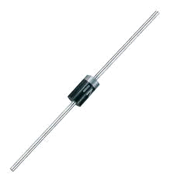

Fig.14: 1N4007 Diode

**2.2.12 CAPACITOR:**

Capacitor is a passive 2 terminal electrical component that stores electrical energy when they are connected to battery or some other charging circuit. The effect of capacitor is known as capacitance. The capacitor contains 2 metallic plates that are separated by some form of insulation. Capacitance is usually measured in the farad unit. They are commonly placed in electronic components and are used to maintain a power supply while the device is unplugged and without a battery for a short time.

Here, in our project we are using 0.1uf, 100uf, 450uf, 470uf.

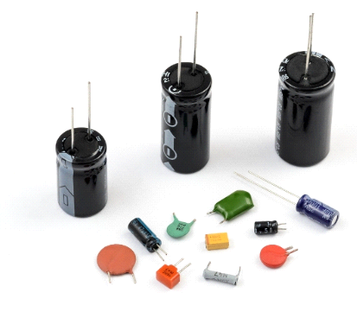

Fig.15: Capacitors

**2.2.13 RESISTORS:**

A resistor is a passive two-terminal electrical component that implements electrical resistance as a circuit element. Resistors act to reduce current flow, and, at the same time, act to lower voltage levels within circuits. Here, in our project we are using 10Ω, 1kΩ, 2.2KΩ and 10KΩ.



Fig.16: (a) resistor (b) rheostat (variable resistor) and (c) potentiometer

**2.2.14 Voice Recognition Module**

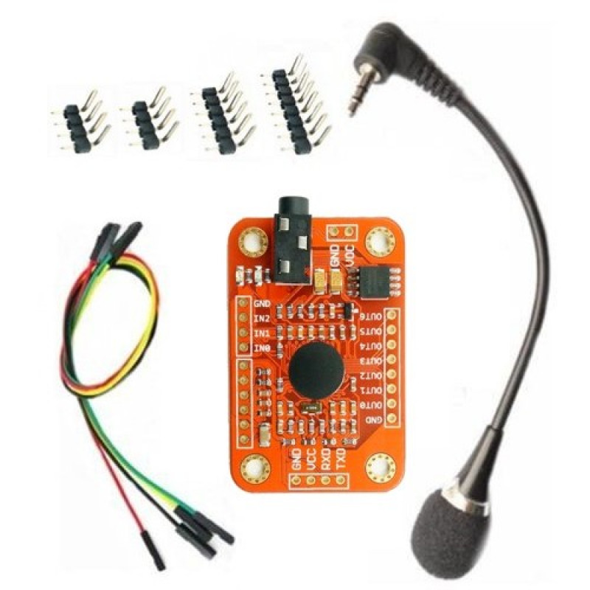

Fig.17: Voice Recognition Module

This Voice Recognition Module is a compact and easy-control speaking recognition board. This product is a speaker-dependent voice recognition module. It supports up to 80 voice commands in all. Max 7 voice commands could work at the same time. Any sound could be trained as command. Users need to train the module first before let it recognizing any voice command.

This board has 2 controlling ways: Serial Port (full function), General Input Pins (part of function). General Output Pins on the board could generate several kinds of waves while corresponding voice command was recognized.

Features of Voice recognition Module:-

* Input Power supply- 12 Volt DC/2 Ampere
* TRAIN1 Switch for to Record First Group
* TRAIN2 Switch for to Record second Group
* Each Group Stores 7 Voices
* LOAD1 Switch to Load Trained First Group voices
* LOAD2 Switch to Load Trained Second Group voices
* PB2,PB3,PB4,PB5 PINS 4BIT DATA OUTPUT

Specifications of Voice recognition Module:-

* Voltage: 4.5-5.5V
* Current: <40mA
* Digital Interface: 5V
* TTL level UART interface
* Analog Interface: 3.5mm mono-channel microphone connector + microphone pin interface
* Size: 30mm x 47.5mm

ISD1820 Recording Module Voice Board With On Board Mic and Loud Speaker

This is ISD1820 Recording Module Voice Board With On Board Mic and Loud Speaker. The ISD1820 Recording Module Voice Board is the real easy way to add Voice Recording (and Playback) to your project. The Module can be operated directly by using the 3 Push-Buttons or with every microcontroller (ex. Arduino).

A microphone is implemented directly on the board, and you can connect any 8 Ohm Speaker. Your recordings are saved even without power due to the non-volatile storage on the ISD1820.

This module uses the ISD1820 voice record and playback IC to record a single voice message of up to 10 seconds in length. The recorded message is stored in its specialized analog flash memory that will keep the message stored even when power is removed.

The module includes an electret microphone to record your message and push buttons to allow for the record, partial playback, or full playback of the message. Header pins allow for easy interface to a microcontroller and playback can be controlled with just one digital pin.

The package includes an 8 Ohm 0.5W speaker and cable which can be connected directly to the module’s speaker output.

Buttons control audio recording method of operation

* REC Button: record button, you can press and hold the recording, release the button to stop recording;
* RLAYE Key: trigger mode playback, press will play this whole speech;
* PLAYL Key: jog mode playback, press and hold until playback, release to stop playback;
* RPL Jumper: loop mode control, loop playback;
* FT Jumper: direct control, microphone voice through the speaker can playback;

Features :

* An easy to use 10 seconds of voice recording.
* High-quality, natural voice restored.
* Can be used as a propaganda module.
* With looping, jog playback, single-pass play function.
* Available single-chip control.
* This module can directly drive a small speaker 8 ohms 0.5W.
* Audio recording control mode: the key to control or microcontroller, IO has drawn the line of control.

**2.2.15 ESP 8266 Wi-Fi module**

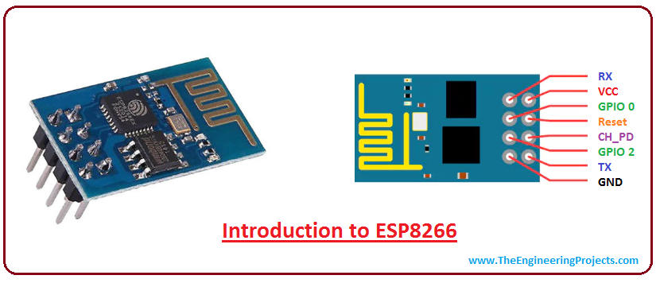

Fig.18: ESP8266 Wi Fi Module

The ESP8266, developed by Espressif Systems, is a low-cost, highly integrated Wi-Fi microcontroller module. It was first introduced in 2014, and since then, it has gained immense popularity due to its robust features and compact size. The ESP8266 has played a pivotal role in revolutionizing the Internet of Things (IoT) landscape, allowing developers to create connected devices easily and cost-effectively.

**Features**

* The ESP8266 module boasts a range of impressive features that make it a favorite among electronics enthusiasts, hobbyists, and professional engineers:
* Low Cost: One of the key attractions of the ESP8266 is its affordability. It offers robust Wi-Fi capabilities at a fraction of the cost of many other alternatives.
* Integrated Wi-Fi: The ESP8266 module features a built-in Wi-Fi module, allowing devices to connect to local networks and the internet seamlessly.
* Small Form Factor: The ESP8266 is incredibly compact, making it suitable for small-scale projects and applications where space is limited.
* Processor Power: Despite its small size, the ESP8266 is equipped with a powerful microcontroller unit (MCU) with ample processing power for various applications.
* GPIO Pins: The module has a series of General-Purpose Input/Output (GPIO) pins, making it versatile for interfacing with sensors, actuators, and other peripherals.
* Programming Flexibility: The ESP8266 can be programmed using various programming languages and integrated development environments, including Arduino IDE, MicroPython, and Lua.
* Firmware Updates: It is possible to update the module's firmware, ensuring that it remains compatible with the latest protocols and security standards.
* Deep Sleep Mode: The ESP8266 includes a deep sleep mode, allowing for power-efficient operation in battery-powered devices.
* Over-the-Air (OTA) Updates: OTA updates enable remote programming and firmware updates, eliminating the need for physical access to the device.
* Wi-Fi Security: The module supports various Wi-Fi security protocols, including WPA/WPA2, ensuring secure data transmission.

**2.2.16 DS18B20 (Temp) Sensor**

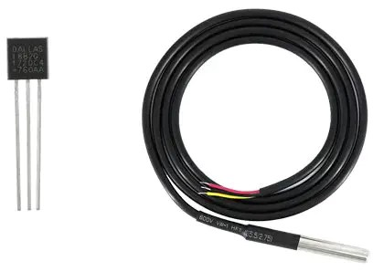

Fig.19: ds18b20 sensor

**Working Principle:**

The DS18B20 is a digital thermometer that operates based on the principles of the One-Wire protocol. It uses a 1-Wire communication bus, which means it requires only one data line for communication with the microcontroller. This simplifies the wiring and makes it easy to interface with microcontrollers like the Arduino.

**Key Features:**

* High Precision: The DS18B20 offers high-precision temperature measurements with a resolution of up to 12 bits, allowing for temperature readings as fine as 0.0625°C.
* Wide Temperature Range: It is designed to operate over an extended temperature range, typically from -55°C to +125°C, making it suitable for both extreme cold and hot environments.
* Multiple Sensors on a Single Bus: The One-Wire protocol allows you to connect multiple DS18B20 sensors to a single microcontroller, each with a unique 64-bit ROM code, enabling multi-point temperature monitoring.
* Parasite Power Mode: The DS18B20 can operate in a "parasite power" mode, where it derives power from the data line, eliminating the need for a separate power source connection.
* Waterproof Versions: Some DS18B20 sensors come in waterproof packages, making them ideal for applications in wet or outdoor environments.
* Low Power Consumption: This sensor has low power requirements, making it suitable for battery-powered applications.

**Communication:**

The DS18B20 communicates with a microcontroller through the One-Wire protocol, where it sends digital temperature data to the microcontroller. The microcontroller can request a temperature reading from the sensor, and the DS18B20 will respond with the temperature data. The communication is digital, and the sensor uses a unique 64-bit ROM code to identify itself on the bus.

**Applications:**

* The DS18B20 temperature sensor finds a wide range of applications, including but not limited to:
* Environmental Monitoring: Used in weather stations, greenhouses, and outdoor temperature monitoring systems.
* Industrial Automation: Integrated into industrial control systems for temperature monitoring and control.
* HVAC Systems: Employed in heating, ventilation, and air conditioning systems for temperature regulation.
* Consumer Electronics: Found in appliances like thermostats, coffee makers, and refrigerators.
* Scientific Research: Used in scientific experiments, laboratories, and research projects for accurate temperature measurements.

**Interfacing:**

The DS18B20 can be easily interfaced with popular microcontroller platforms like Arduino and Raspberry Pi using the One-Wire library or similar libraries. You need to connect the sensor's data pin to a digital input/output pin on the microcontroller and provide it with the necessary power supply.

**Accuracy and Calibration:**

The DS18B20 provides accurate temperature measurements; however, it's essential to calibrate the sensor for the most precise results in specific applications. Calibration involves comparing the sensor's readings to a known, accurate temperature source and adjusting the readings accordingly.

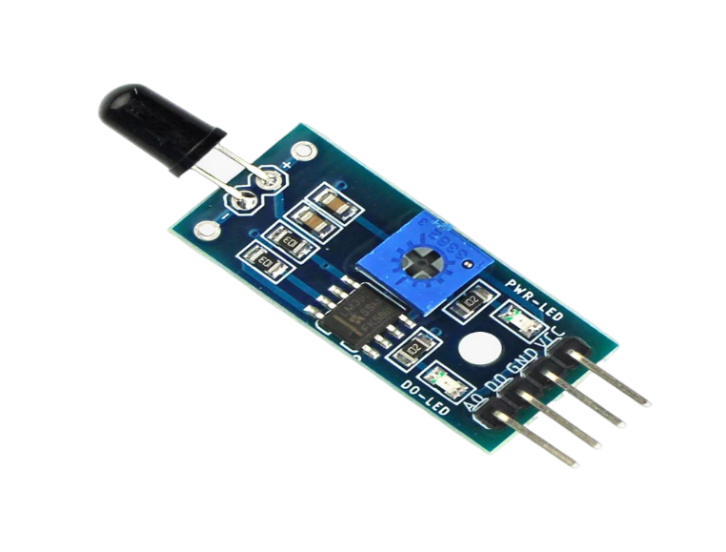**2.2.17 Flame Sensor**

Fig.20: Flame sensor

The Flame Sensor Module can detect flames in the 760-1100 nanometer wavelength range. Small flames like a lighter flame can be detected at roughly 0.8m. The detection angle is roughly 60 degrees and the sensor is particularly sensitive to the flame spectrum.

An on-board LM393 op-amp is used as a comparator to adjust the sensitivity level. The sensor has a digital and analog output and sensitivity can be adjusted via the blue potentiometer.

It is based on the YG1006 sensor which is a high speed and high sensitive NPN silicon phototransistor. Due to its black epoxy, the sensor is sensitive to infrared radiation.

The sensor can be a great addition in a firefighting robot, it can be used as a robot eyes to find the fire source. When the sensor detects flame the Signal LED will light up and the D0 pin goes LOW.

**Features :**

* High Photo Sensitivity
* Fast Response Time
* Sensitivity adjustable
* Detects a flame or a light source of a wavelength in the range of 760nm-1100 nm.
* Detection range: up to 100 cm.
* Adjustable detection range.
* Detection angle about 60 degrees, it is sensitive to the flame spectrum.
* Comparator chip LM393 makes module readings stable.
* Operating voltage 3.3V-5V.
* Digital and Analog Output.
* Power indicator and digital switch output indicator.

**Specifications :-**

* Operating Voltage (VDC) 3.3 ~ 5
* Spectrum range 760nm ~ 1100nm
* Detection Angle() 0 to 60
* Operating Temperature (C) -25 to 85
* Length (mm) 35.5
* Width (mm) 15.2
* Height (mm) 14
* Weight (gm) 3

**2.2.18** **ISD1820 audio player module**



Fig.21: ISD1820 audio player module

This is ISD1820 Recording Module Voice Board With On Board Mic and Loud Speaker. The ISD1820 Recording Module Voice Board is the real easy way to add Voice Recording (and Playback) to your project. The Module can be operated directly by using the 3 Push-Buttons or with every microcontroller (ex. Arduino). A microphone is implemented directly on the board, and you can connect any 8 Ohm Speaker. Your recordings are saved even without power due to the non-volatile storage on the ISD1820.

This module uses the ISD1820 voice record and playback IC to record a single voice message of up to 10 seconds in length. The recorded message is stored in its specialized analog flash memory that will keep the message stored even when power is removed.The module includes an electret microphone to record your message and push buttons to allow for the record, partial playback, or full playback of the message. Header pins allow for easy interface to a microcontroller and playback can be controlled with just one digital pin.

Buttons control audio recording method of operation

* REC Button: record button, you can press and hold the recording, release the button to stop recording;
* RLAYE Key: trigger mode playback, press will play this whole speech;
* PLAYL Key: jog mode playback, press and hold until playback, release to stop playback;
* RPL Jumper: loop mode control, loop playback;
* FT Jumper: direct control, microphone voice through the speaker can playback;

**Features :**

* An easy to use 10 seconds of voice recording.
* High-quality, natural voice restored.
* Can be used as a propaganda module.
* With looping, jog playback, single-pass play function.
* Available single-chip control.
* This module can directly drive a small speaker 8 ohms 0.5W.
* Audio recording control mode: the key to control or microcontroller, IO has drawn the line of control.

**2.3 CIRCUIT DIAGRAM:**

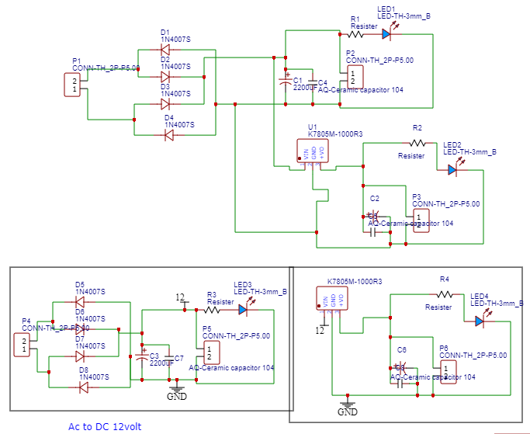

Fig.22: Circuit Diagram of Power Supply

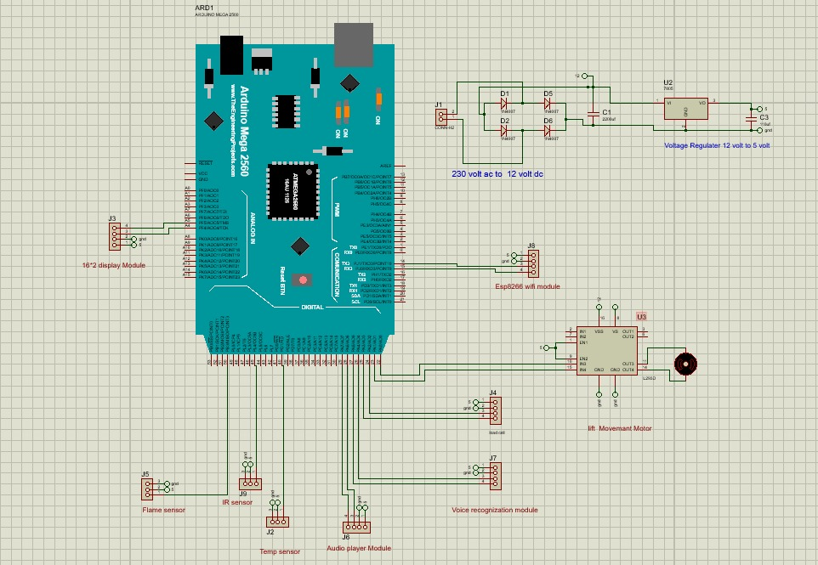

Fig.23: Circuit Diagram of controller